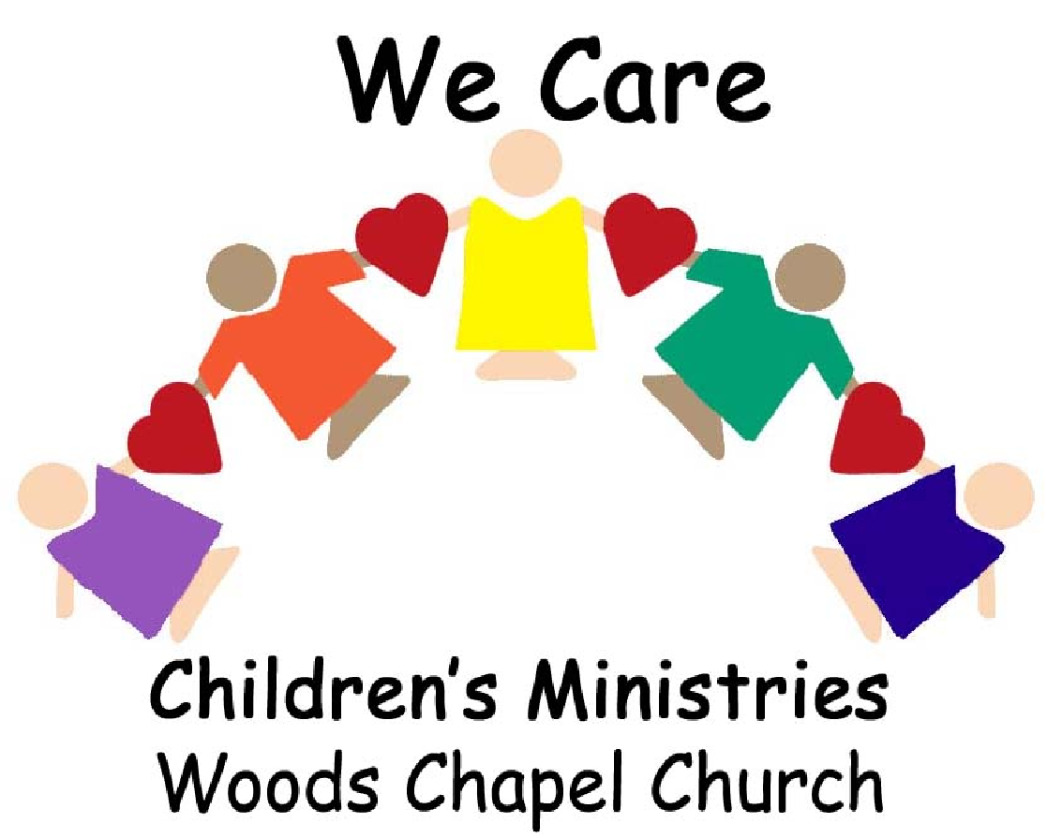
4725 NE Lakewood Way
Lee’s Summit, MO 64064
(816) 373-4904

Religious Organization Child Care Facility
Notice of Parental Responsibility

Section 210.211 RSMo exempts this religious organization child care facility from state licensing and supervision by the Department of Health and Senior Services (DHSS). It is state inspected only for fire, health and sanitation requirements as indicated below. Copies of the inspections are available.

Inspections: Agency Name, Address & Telephone Number | Date
MO Department of Health – Bureau of Child Care (Health and Safety Inspection)  3717 S Whitney Avenue, Independence, MO 64055 (816) 350-5450 | Approved 10/27/16
Fire Marshal’s Office – (Fire Safety Inspection)  1709 Industrial Drive, Jefferson City, MO 64102 (660) 543-5048 | Approved 07/18/16
Local Health Office or DHSS (Sanitation Inspection)  1709 Industrial Drive, Jefferson City, MO 64102 (573) 751-2930 | Approved 08/25/16

Standard Staff/Child Ratios Established by This Facility: Standard Staff/Child Ratios for Licensed Centers:

Age Range | Staff to Child Ratio
Under 2 years | 1 to 4
2 years | 1 to 8
3 and 4 years | 1 to 10
5 years and older | 1 to 16

Age Range | Staff to Child Ratio
Under 2 years | 1 to 4
2 years | 1 to 8
3 and 4 years | 1 to 10
5 years and older | 1 to 16

Total number of children enrolled by this facility: 375

BACKGROUND CHECKS: CHILD ABUSE/NEGLECT AND CRIMINAL RECORD(S)
Statute 210.254 RSMo requires the facility to conduct background checks for child abuse/neglect and criminal record reviews on each individual caregiver and all other personnel (who have contact with children in care) at the facility at the time of employment and every two years thereafter.
Background checks for child abuse and neglect through the Children’s Division (CD) and criminal record reviews through the Missouri State Highway Patrol have been conducted on each individual caregiver and all other personnel at the facility as required.
Yes ___X__ No ______

FACILTIY DISCIPLINE AND EDUCATIONAL PHILOSOPHY/POLICIES
Our purpose is to help each child retain control of their emotions and actions, NOT to stop them from expressing feelings and needs. Our goal is to equip children with the tools to make appropriate choices. Through positive reinforcement, redirection and modeling, we will guide them in this process. When a child displays unacceptable behavior, the teacher will choose an appropriate discipline such as time away from others to think about the behavior. Physical punishment is NEVER used, nor are the children subjected to frightening, humiliating, embarrassing or emotionally harmful situations or remarks. The child needs, above all, our love, patience, understanding and respect.

THE EDUCATION PHILOSOPHY AND POLICIES OF THIS FACILITY ARE:
We Care Children’s Ministries will provide a warm, loving, Christian environment for each child. We provide a place where a child can continue to develop a positive self-image through quality education programs while still enjoying the laughter and fun of childhood. All areas of a child’s development are important. We Care is committed to providing developmentally appropriate activities for all ages.

REQUIRED SIGNATURES
Statute 210.254 RSMo requires the facility to furnish two copies of this document to a parent(s) upon enrollment of a child. Parents acknowledge by signature that they have read and accepted the information contained in this document. One copy of this signed document is given to the parent(s); the other copy is retained in the child’s record at the facility.

_
Child’s Name Parent Signature Date

_
Peggee Schwartz, Director Robyn Miller, Pastor Date
Principal Operating Officer/Facility Director Individual Responsible for the Religious Organization

NOTIFICATION OF PARENTAL RESPONSIBILITY

Pursuant to section 210.254, RSMo Supp. 2000, the NPR will require:

“1) Notification that the child care facility is exempt as a religious organization from state licensing and therefore not inspected or supervised by the department of health and senior services other than as provided herein and that the facility has been inspected by those designated in section 210.252 and is complying with the fire, health and sanitation requirements of sections 210.252 to 210.257;

“2) The names, addresses and telephone numbers of agencies and authorities which inspect the facility for fire, health and safety and the date of the most recent inspection by each;

“3) The staff/child ratios for enrolled children under two years of age, for children ages two to four and for those five years of age and older as required by the department of health and senior services regulations in licensed facilities, the standard ratio of staff to number of children for each age level maintained in the exempt facility, and the total number of children to be enrolled by the facility;

“4) Notification that background checks have been conducted on each individual care giver and all other personnel at the facility. The background check shall be conducted upon employment and every two years thereafter on each individual care giver and all other personnel at the facility. Such background check shall include a screening for child abuse or neglect through the children’s division, and a criminal record review through the Missouri Highway Patrol pursuant to section 43.540, RSMo. The fee for the criminal record review shall be limited to the actual costs incurred by the Missouri Highway Patrol in conducting such review not to exceed ten dollars;

“5) The disciplinary philosophy and policies of the child care facility; and

“6) The educational philosophy and policies of the child care facility.”

Statute 210.254 RSMo requires a new facility to file a copy of the Notice of Parental Responsibility with the Section for Child Care Regulation at least five days prior to beginning operation. Each facility must file the Notice of Parental Responsibility annually during the month of August.

